W-16
YEAR 8 SCIENCE
BIOLOGICAL SCIENCE
REVISION - MICROSCOPES + CELLS

1. (a) Label the following diagram of a microscope.

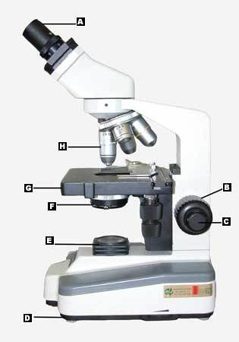

(b) It is suggested that you look at the slide from the side when switching from low to high power. Why is this?

(c) If the eyepiece is X10 and the objective lens is X4, what is the magnification of the slide?

(d) If you look into the microscope and observe the slide in focus, what happens to the image if you move the slide to the right?

(e) The microscopes used at Holy Cross have three objective lenses that can be adjusted to give low, medium and high power viewing of slides.

When is it best to use the fine focus knob when viewing a slide? Explain why.

2. (a) Label the following diagram of a cell.

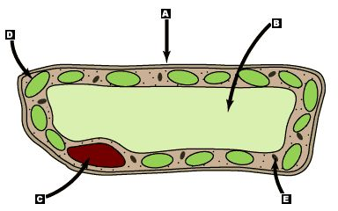

(b) Is it a plant or animal cell? How do you know?

(c) Name the parts of the cell that do the following functions.

Part of Cell | Function
 | Controls the activities of the cell.
 | Storage area for substances needed by the cell.
 | Controls substances entering and leaving cells.
 | Contains chlorophyll and is the site for photosynthesis.
 | Only found in plants – gives the cell strength and helps plants stay upright.
 | Produces energy for the cell.
 | Jelly-like liquid that fills up most of the space in a cell.

3. List three ways in which a plant cell is different to an animal cell.

•

•

•

4. Unscramble the words using the clues provided.

(a) Control centre of the cell. SEUNCLU

(b) Surrounds the cell. ERAMMBNE

(c) Contains cell sap. OCVAUEL

(d) Part of the cell between the cell membrane and
the nucleus. CATOPLMYS

(e) Building blocks of all living things. LELSC

(f) Living things . ASMOGNIRS

5. Copy and complete the table below.

